***Screenshots of E-Circuits of Logic Gates.***

*1. AND Gate.*

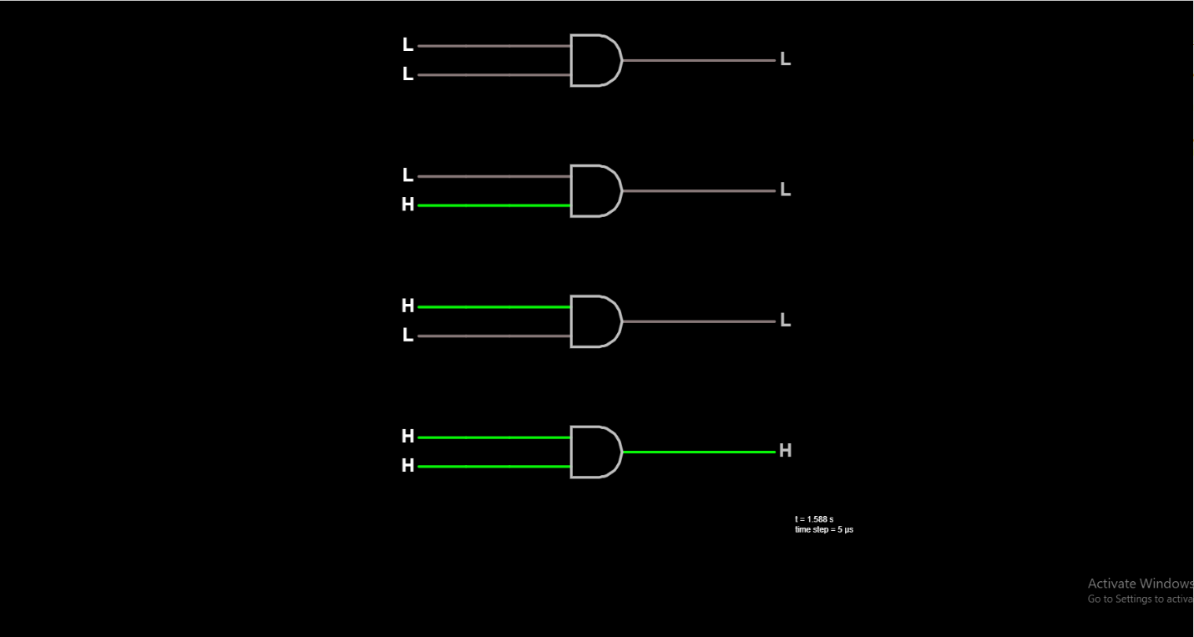

*2. OR Gate.*

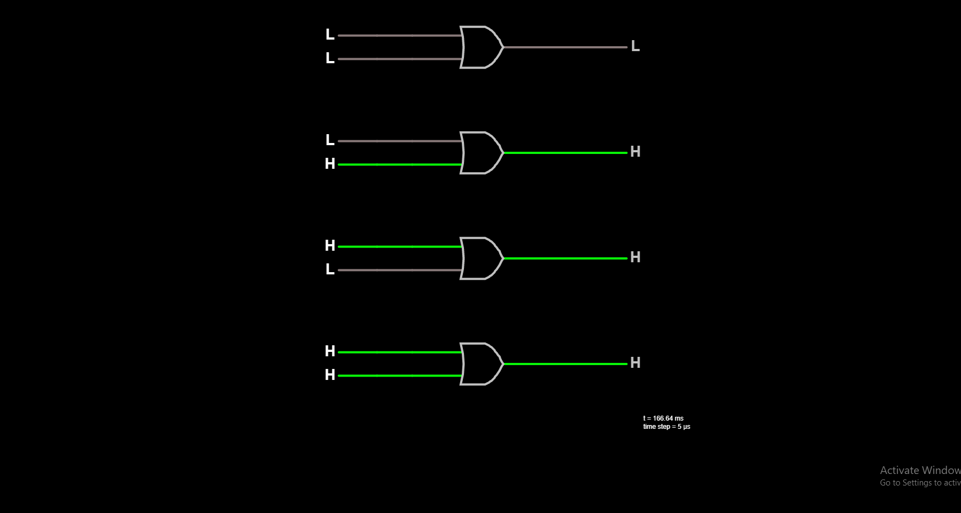

*3. NOT Gate.*

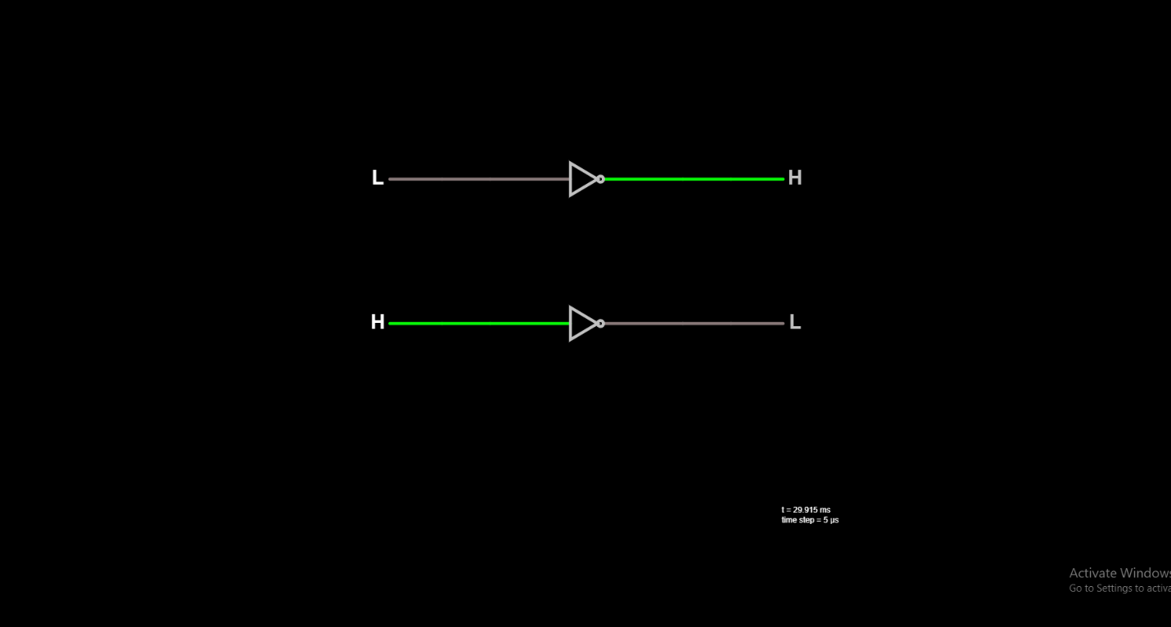

*4. NAND Gate.*

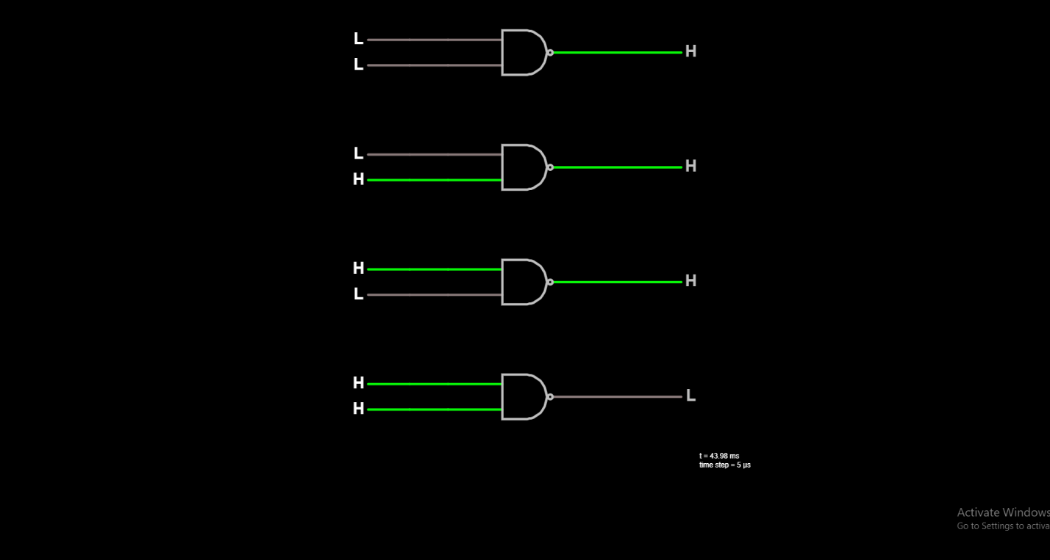

*5. NOR Gate.*

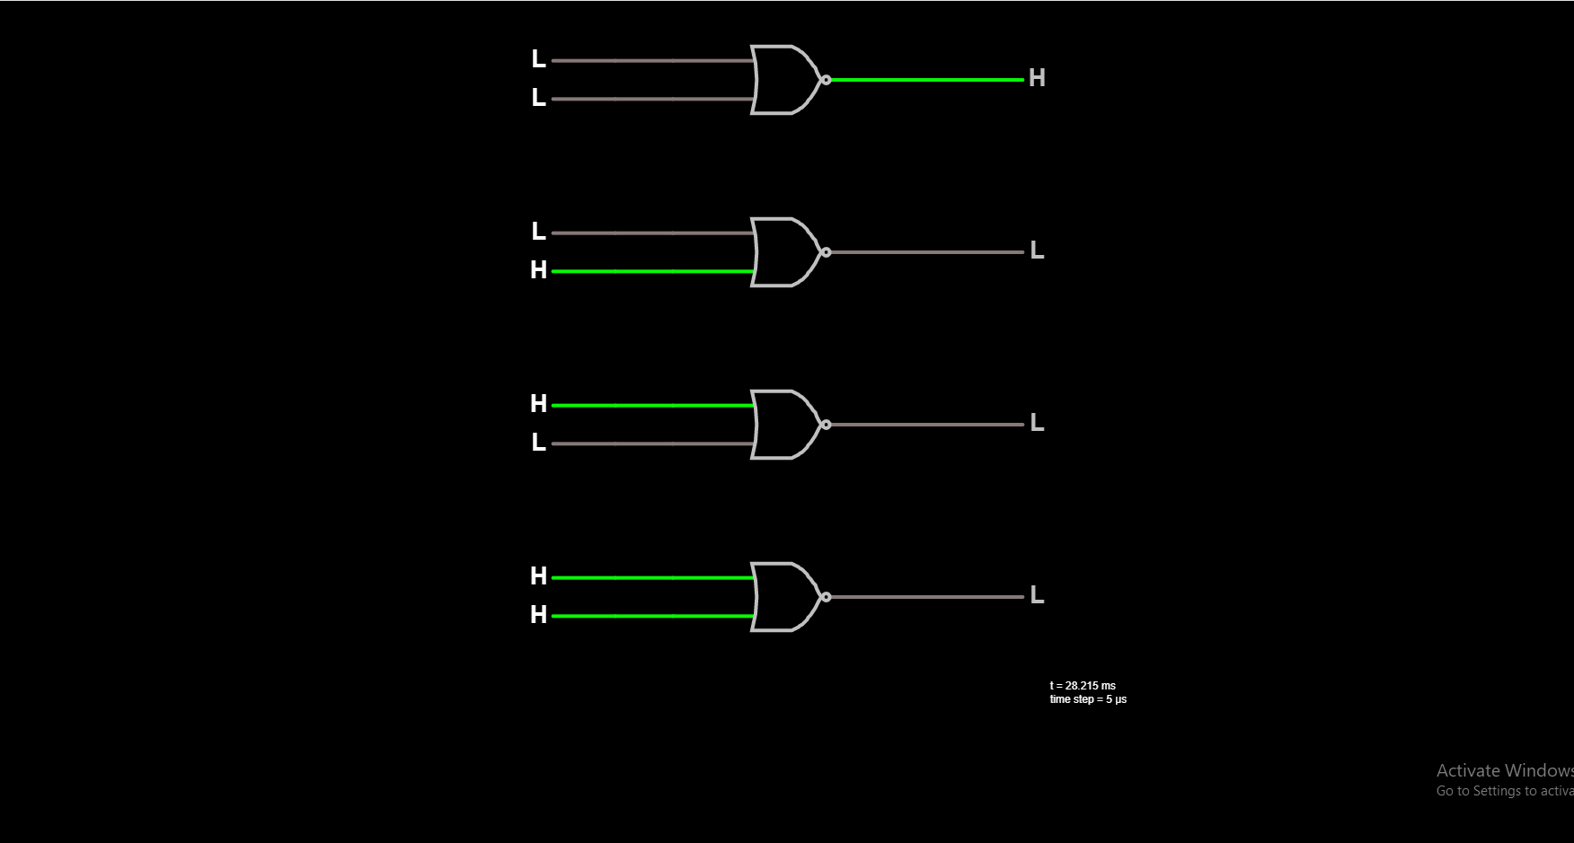

*6. X-OR (Exclusive OR) Gate.*

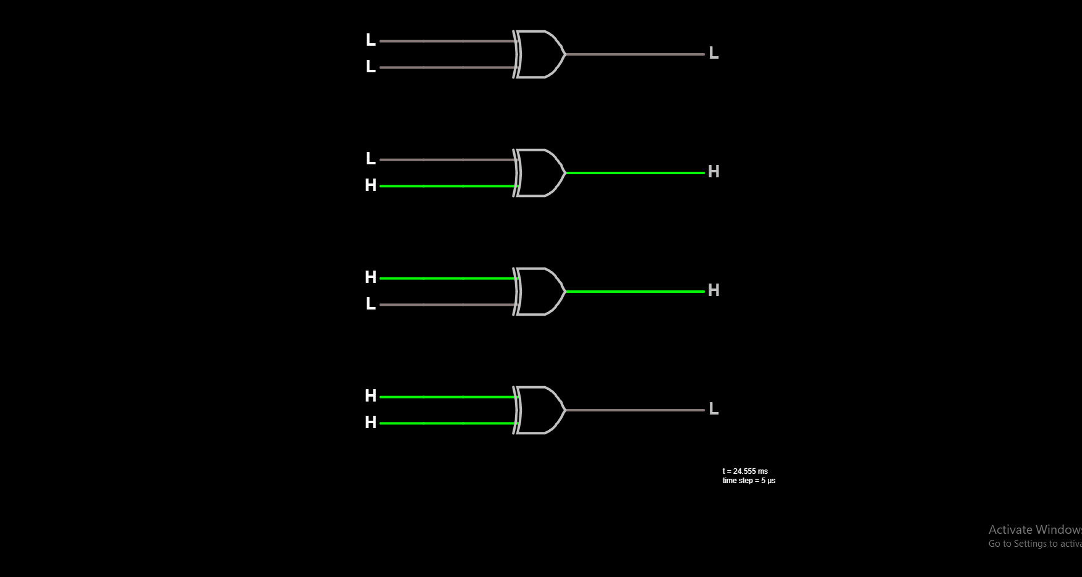

*7. X-NOR (Exclusive NOR) Gate.*

